First A. Author  (Helvetica 10 pt, bold)  Affiliation-Professor  Institution or Company-  University of Belgrade  Faculty of Mechanical Engineering  (Helvetica 7,5 pt)  Second B. Author  (Helvetica 10 pt, bold)  M.Sc. dipl. ing. el.  J. P. ”EPS” Belgrade  TPP ” N. Tesla”  (Helvetica 7,5 pt)  Third C. Author  (Helvetica 10 pt, bold)  Assistant Professor  University of Nis  Faculty of Mechanical Engineering  (Helvetica 7,5 pt) | Title (Helvetica 16 pt, bold)  Type the abstract of not more than 150 words outlining description of the problem, method used and conclusions. The abstract is an essential part of the paper. Use short, direct, and complete sentences. It should be as brief as possible and concise. It should be complete, self-explanatory, and does not require reference to the paper itself. The abstract should be informative, giving the scope and emphasizing the main conclusions, results, or significance of the work described. Do not use first person; do not include mathematical expressions; do not refer to the reference, and try to avoid acronyms. Use this document as a template for MS Word, version 97 or later. Otherwise, use this document as an instruction set (Times New Roman 10 pt, Italic).  Keywords (Times New Roman 10 pt, Bold): 5-8 keywords, left justified (Times New Roman 10 pt, Italic).

- INTRODUCTION (all caps - Helvetica 9 pt, bold) - Align left

These are instructions for authors typesetting for the Journal FME TRANSACTIONS. This document has been prepared using the required format. The paper must be written in correct English (English or American spelling). If the quality of the language is too poor, this can prevent your paper from being included in the Proceedings. For the good appearance of the Proceedings it is of intrinsic importance that all full texts are of the same shape. The paper is to be written in two-column format on the paper size A4 and be right and left justified, using single spacing (Times New Roman 10) The width of all margins is to be 20 mm. The width of each column is to be 80 mm, and the gap between columns should be 10 mm (Format>Columns).
The paragraph indentation is to be 5 mm (Format>Paragraph>Indents and Spacing>Special: First line by 5 mm).
Leave one clear line before and after a main or secondary heading.
We recommend to start with an Introduction where you formulate your problem or task respectively, present the state-of-the-art and establish the position of your work in the international scene.

- main heading (capital letters, align left - Helvetica 9 pt, bold)

Please use this document as a template to prepare your manuscript.
In left bottom corner put the full mailing and email addresses of the corresponding author and his affiliation, as presented below.

  - Secondary heading (Helvetica 9 pt, bold) – Align left

Avoid leaving a heading at the bottom of a column, with the subsequent text starting at the top of the next page/column.
Do not use further subdivision, for instance 2.1.1. is not allowed.
Use Word program Equations editor to type all formulas (size 10). For subscripts and superscripts use letter size 8. Denotation typewritten in the text should be set in italic, size 10.
Mathematical formulas should be centred and have to be numbered consecutively from 1 in parentheses on the far right margin of the column, as formula (1):
. (1)
Equations are separated by 6 points from the rest of the text, for example, (Format>Paragraph>Indents and Spacing>Spacing>Before 6 pt, After 6 pt).
All numbers and brackets in the text and formulas are to be vertical.
All variables: a, b, ... , x, y, z, should be set in italic, while the mathematical operators and functions should be vertical, as for example:
, , , , , , .(2)
Indexes should be set according to the pre-given rules, i.e. if index is a number or a letter it should be set vertically. However, if index presents a symbol of a variable it should be set in italic, as for instance:
. (3)
Vectors are to be written with arrow head as presented below:
, , (4)
or should be set in bold:
, . (5)
Nondimensional numbers as e.g. Reynold's, should be set in italic:
Re, ... (6)
Full point and comma have to be typewritten in the text and not in Word Equation Editor.
Refer to (1), not to Eq. (1), or equation (1), except at the beginning of a sentence. Be sure that the symbols in your equation have been defined before the equation appears or immediately following.
SI units are strongly encouraged. Do not use English units. Avoid combining different units. This often leads to confusion because equations do not balance dimensionally. If you must use mixed units, clearly state the units for each quantity in an equation.
Units should be typewritten vertically, as for example:
or .
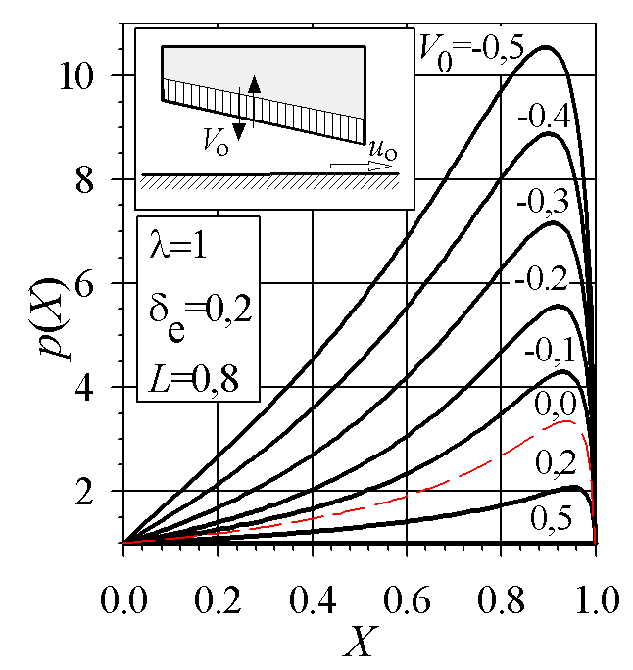
Figure 1. Title (Helvetica 8 pt, bold) – Align left
Restrict figures to single-column width unless this would make them illegible. If necessary for the purpose of clarity they can be spread over both columns. Coloured figures will be reproduced in colour only in electronic version of the Journal, while they will not be reproduced in colour in printed version, so it is not recommended to use coloured figures and photographs. If possible, do not assemble figures at the back of your article, but place them as close as possible to where they are mentioned in the main text.
Figures, numbered consecutively with captions, should be incorporated into the main body of the text. Do not put figures in frames.
Do not insert text along the figure by using Insert + Tex Box. Do not put captions in text boxes linked to the figures. Do not put borders around the outside of your figures.
Figures should be centred (Format Object + Layout + In line with text).
No part of a figure should go beyond the typing area. Captions should appear below graphical objects.
Figures are to be inserted in their proper place throughout the paper and not to be grouped together. Please use only drawings and photographs of excellent quality. It is especially important that all numbers and characters appearing in your figures are of good quality and well-readable size (≈8-10 pt), i.e. approximately of the same size as your text. Figure axis labels are often a source of confusion. Axes labels must be clearly denoted. Figure labels should be legible, approximately 8 to 10 point type.
Captions should appear below graphical objects. Captions are the part of the text and not of the figures. Number and title of the figure are separated from figure and main text by 6 pt (Format>Paragraph>Indents and Spacing>Spacing>Before 6 pt, After 6 pt), as shown in these instructions.
All tables should be incorporated into the main body of the text and must be centred in the column and numbered consecutively (in Arabic numbers).
Place tables as close as possible to where they are mentioned in the main text. Large tables may span both columns.
Table headings should be placed above the table, as shown in this template. The width of all lines in tables including all borders should be 1/2 pt. Text and numbers in tables should be typewritten in Times New Roman, 9 pt.
Table 1. Heading (Helvetica 8 bold) – Align left
Element | Chemical composition (%)
Element | SiO₂ | Al₂O₃ | Fe₂O₃ | CaO
Cordierite (C) | 45.52 | 28.10 | 1.23 | 3.70
Talc (T) | 62.20 | 3.11 | 1.25 | 1.07

It is recommended that footnotes be avoided. Instead, try to integrate the footnote information into the text.
Define abbreviations and acronyms the first time they are used in the text, even they have already been defined in the abstract. Do not use abbreviations in the title unless they are unavoidable (for example “ASME”).
References to relevant literature are to be given in usual format, please consult the sample references at the end of theses instructions. References are to be listed in the order of their appearance in the text and numbered. Citation is by the number only which is to be put in square brackets, i.e. [1], [2], ... etc.

- CONCLUSION (Helvetica 9 bold) - Align left

A conclusion section is not required, but it is strongly recommended. Although a conclusion may review the main points of the paper, do not replicate the abstract as the conclusion. A conclusion might elaborate on the importance of the work or suggest applications and extensions.
appendix (Helvetica 9 bold, Align left)
Appendixes, if needed, appear before the acknowledgment. Do not include page numbers in the text.
acknowledgment (Helvetica 9 bold, Align left)
Use the singular heading even you have many acknowledgments. Also put in this section sponsor and financial support acknowledgments.
REFERENCES (Helvetica 9 bold, Align left)
In the reference list, journal papers [1], books [2], multi-author books [3], theses [4] and conference Proceedings [5] should be cited as in the following examples:

- Beskok, A., Karniadakis, G.E. and Trimmer, W.: Rarefaction and compressibility effects in gas microflows, Trans. ASME - J. Fluids Eng, Vol. 118, No. 3, pp. 448-456, 1996.
- Gross, A. W.: Gas film lubrication, John Wiley and Sons, New York, 1992.
- Stachowiak, G.W.: Numerical Characterization of wear particle morphology, in: Hutchings, I.M. (Ed.): New Directions in Tribology, Mechanical Engineering Publications Ltd., Bury St Edmunds, pp. 371-389, 1997.
- Stokes, J.: Production of Coated and Free-Standing Engineering Components using the HVOF (High Velocity Oxy-Fuel) Process, PhD thesis, School of Mechanical and Manufacturing Engineering, Dublin City University, Dublin, 2003.
- Lancaster, J.K.: Severe metallic wear, in: Proceedings of the Conference on Lubrication and Wear, 01-03.10.1957, London, pp. 1-7 or Paper 72.

Please note that all references listed here must be directly cited in the body of the text. Please do not cite only your work or reports, but give proper reference to relevant related work of easy access, i.e. cite books and articles in journals and conference Proceedings, preferably in English.
If the reference has not been written in English, please translate it into English, and state the original language in brackets, e.g. (in Serbian).
Nomenclature should be put after references, but it is not required.
NOMENCLATURE (Helvetica 9 pt, bold, Align left)
thermal diffusivity for fluid, (Times New Roman 10)
local heat transfer coefficient
Greek symbols (Times New Roman 10 pt, bold, italic)
Kronecker delta
Reynolds or turbulent stress
Superscripts (Times New Roman 10 pt, bold, italic)
co | convective section
f | furnace section

Table 2. Heading – Large tables and figures may span both columns, and if it is not possible to incorporate them in the main text you can position them at the end of the paper (Helvetica 8 bold).
Term | Normal components of Reynolds stress

